CREATE DATABASE addressbook;

USE addressbook;

CREATE TABLE employees_data(

emp_id INT AUTO_INCREMENT PRIMARY KEY,

f_name VARCHAR(50),

l_name VARCHAR(50),

Tittle VARCHAR(30),

age INT,

yos INT,

salary DECIMAL (10,2),

perks DECIMAL (10,2),

email VARCHAR(50)

);

INSERT INTO employees_data values ( 1,'Rudolft', 'Reindeer', 'Business Analyst', 34, 2, 95000, 17000, 'rundolft@bugnetcom');

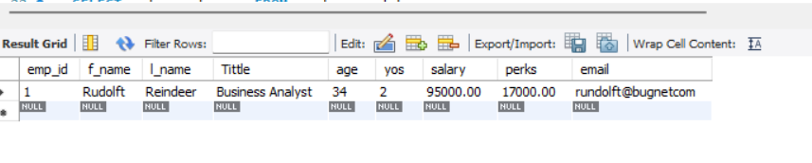SELECT * FROM employees_data;

SELECT f_name, l_name, Tittle, age, yos, salary, perks, email FROM employees_data;

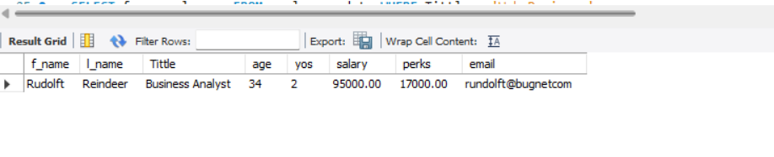

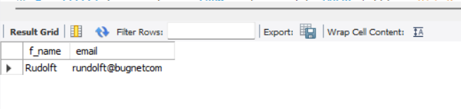SELECT f_name, email FROM employees_data;

SELECT salary, perks, yos FROM employees_data;

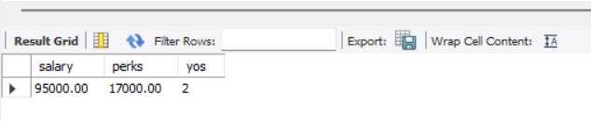

SELECT COUNT(*) FROM employees_data;

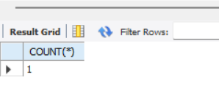

SELECT salary, l_name FROM employees_data;

